1 SERVLET PROGRAM TO WELCOME USER

import java.io.*;

import javax.servlet.*;

import javax.servlet.http.*;

public class HelloWorld3 extends HttpServlet {

public void doGet(HttpServletRequest request, HttpServletResponse response)

throws IOException, ServletException

{

response.setContentType("text/html");

PrintWriter out = response.getWriter();

out.println("<html>");

out.println("<head>");

out.println("<title>Hello World!</title>");

out.println("</head>");

out.println("<body>");

out.println("<h1><MARQUEE BGCOLOR = GREEN>Hello VBIT World!</MARQUEE></h1>");

out.println("<br><br><h1><MARQUEE BGCOLOR = YellOW>created for III CSE -A yr 2012-13</MARQUEE></h1>");

out.println("</body>");

out.println("</html>");

}

}

1.1 WEB.XML

<web-app>

<servlet>

<servlet-name>HelloWorld3 </servlet-name>

<servlet-class>HelloWorld3 </servlet-class>

</servlet>

<servlet-mapping>

<servlet-name>HelloWorld3</servlet-name>

<url-pattern>/vbitHello</url-pattern>

</servlet-mapping>

</web-app>

**1.3 Output** 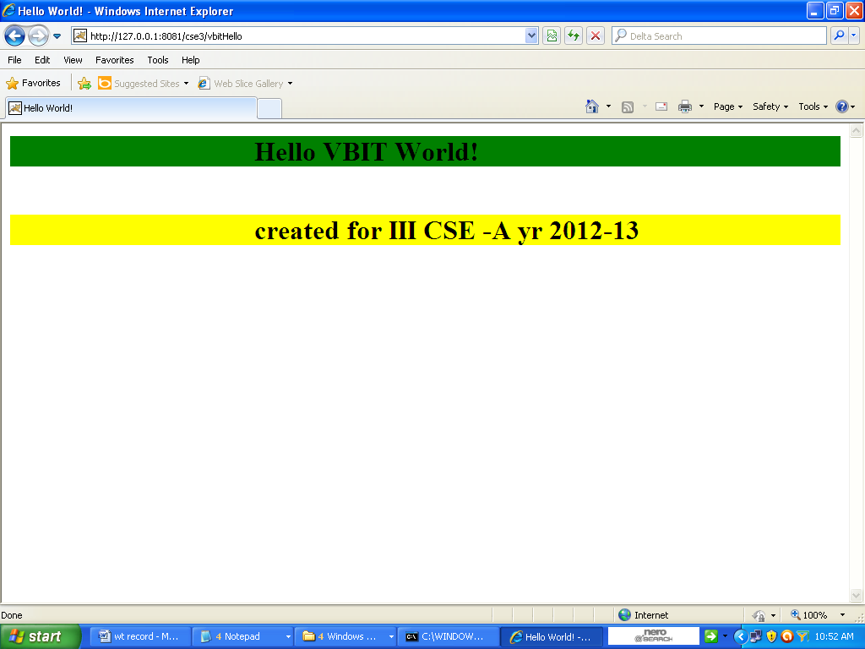

2. servlet program to count number of times servlet Accesse

import java.io.*;

import javax.servlet.*;

import javax.servlet.http.*;

public class SimpleCounter extends HttpServlet {

int count = 0;

public void doGet(HttpServletRequest req, HttpServletResponse res)

throws ServletException, IOException {

res.setContentType("text/plain");

PrintWriter out = res.getWriter();

count++;

out.println("Since loading, this servlet has been accessed " +

count + " times.");

}

}

Output

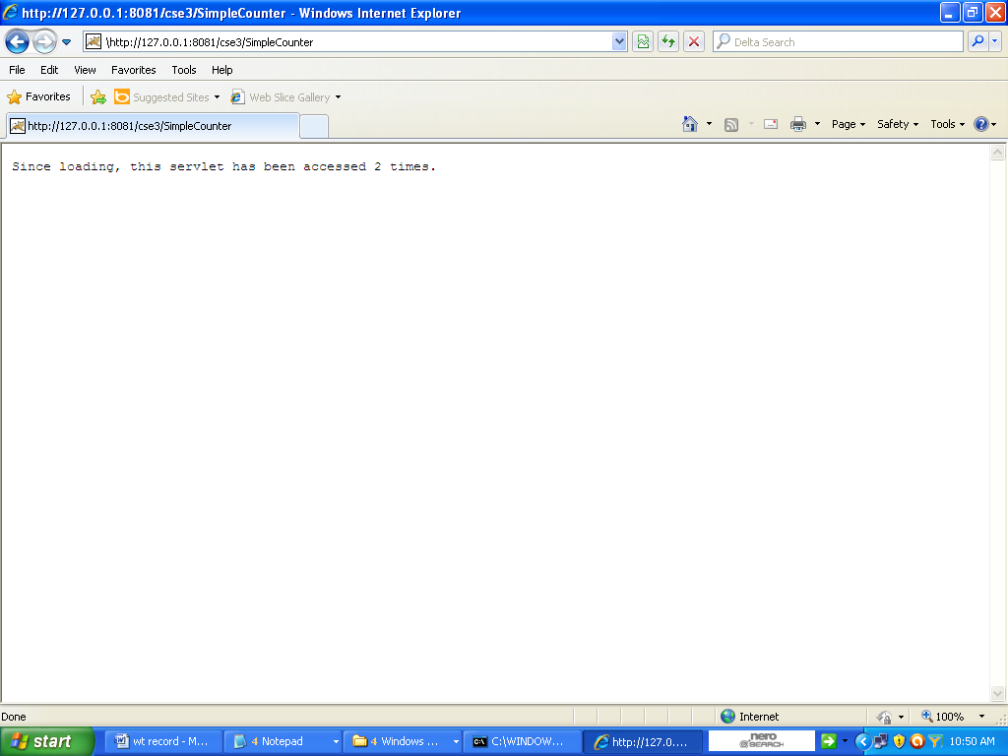

**3. Accessing servlet Through a HTML page**

Or

Servlet program to welcome user with his name (using html forms)

import java.io.*;

import javax.servlet.*;

import javax.servlet.http.*;

public class Hello1 extends HttpServlet {

public void doGet(HttpServletRequest req, HttpServletResponse res)

throws IOException ,ServletException{

res.setContentType("text/html");

PrintWriter out = res.getWriter();

String name = req.getParameter("name");

out.println("<HTML>");

out.println("<HEAD><TITLE>Hello " + name + "</TITLE></HEAD>");

out.println("<BODY>");

out.println("Hello servlet is sending the name of the client <H1><font color= red> " + name+"</font> </H1>");

out.println("</BODY></HTML>");

}

public String getServletInfo() {

return "A servlet that knows the name of the person to whom it's" +

"saying hello";

}

}

3.1 Html page

<HTML>

<HEAD>

<TITLE>Introductions</TITLE>

</HEAD>

<BODY>

<FORM METHOD=GET ACTION=" http://127.0.0.1:8081/cse3/vbit2">

If you don't mind me asking, what is your name?

<INPUT TYPE=TEXT NAME="name"><P>

<INPUT TYPE=SUBMIT>

</FORM>

</BODY>

</HTML>

Web.xml

<web-app>

<servlet>

<servlet-name>Hello1 </servlet-name>

<servlet-class>Hello1 </servlet-class>

</servlet>

<servlet-mapping>

<servlet-name>Hello1</servlet-name>

<url-pattern>/vbit2</url-pattern>

</servlet-mapping>

</web-app>

Out put:1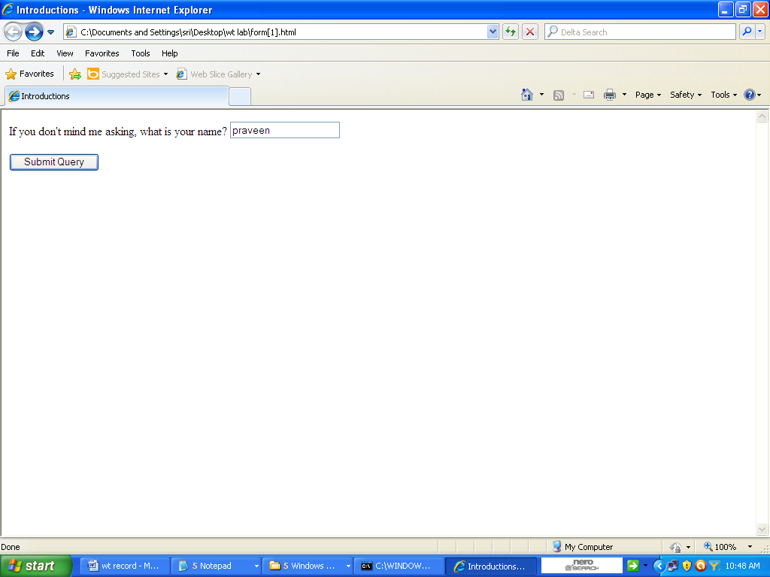

Output2

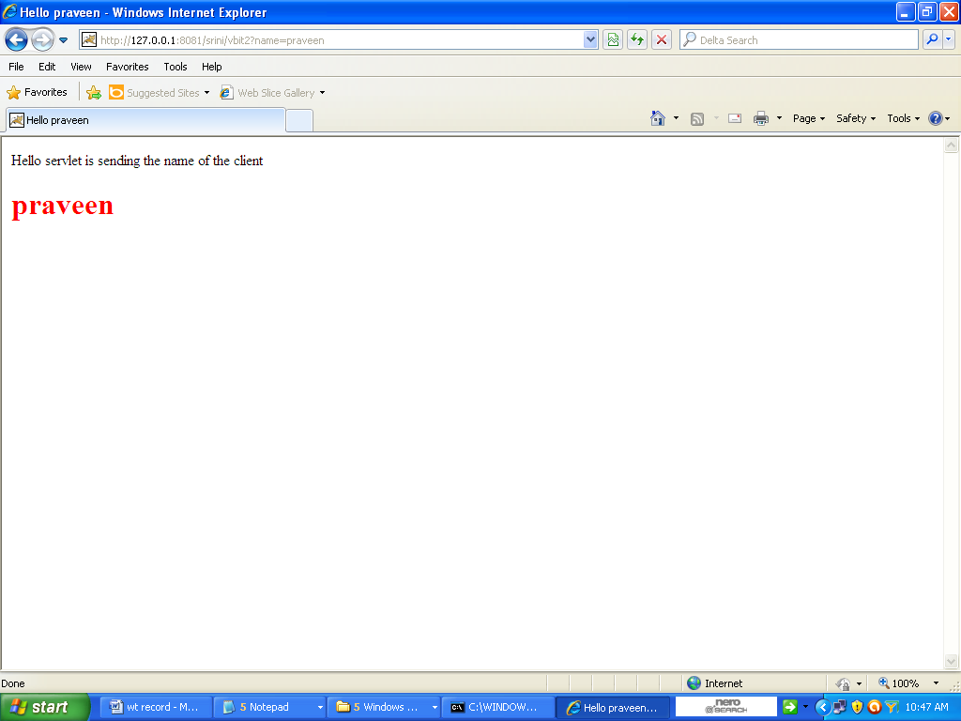

4 Servlet program using Cookies

/* Shows how to store client state by using cookies

4.1 Creates cookie

*/

import java.io.*;

import javax.servlet.*;

import javax.servlet.http.*;

public class FFCookie extends HttpServlet

{

public void doGet (

HttpServletRequest request,

HttpServletResponse response

) throws ServletException, IOException

{

PrintWriter out;

// set content type and other response header fields first

response.setContentType("text/html");

// then write the data of the response

out = response.getWriter();

//get values submitted by the form

String name = request.getParameter("name");

String fname = request.getParameter("Fname");

// create a cookie to store the values of name and fname

Cookie c1 = new Cookie("name",name);

Cookie c2 = new Cookie("fname",fname);

response.addCookie(c1);

response.addCookie(c2);

// now we need to genetare the second form dynamically from here

out.print("<html> <head> <title>Income tax details -form XXX - Page no -2 </title>");

out.print(" </head> <body bgcolor=#ffffff>");

out.print("<form action=\"SFCookie\" method=get>");

out.print("income for this year <input type=text name=income> <BR>");

out.print(" Tax<input type=text name=tax>");

out.print("<br><br> <BR><BR><input type=submit value = submit>");

out.print("</form> </font> </body> </html>");

out.close();

}

}

4.1 html program to access servlet

<!DOCTYPE HTML PUBLIC "-//IETF//DTD HTML//EN">

<html>

<head>

<title>Income tax details -form XXX - Page no -I </title>

</head>

<body bgcolor=#ffffff>

<font face="helvetica">

<form action= "http://127.0.0.1:8081/cse3/FFCookie" method=GET>

name <input type=text name=name> <BR>

Father name <input type=text name=Fname>

<br><br> Like this u can have any no of fields <br><br>

<br > After filling this form submit this form by clicking continue <br>

, then continue filling second form<br>

<BR><BR><input type=submit value = continue>

</form>

</font>

</body>

</html>

4.2 Second servlet program to read cookie

/* Shows how to store client state by using cookies

*/

import java.io.*;

import javax.servlet.*;

import javax.servlet.http.*;

public class SFCookie extends HttpServlet

{

public void doGet (

HttpServletRequest request,

HttpServletResponse response

) throws ServletException, IOException

{

PrintWriter out;

// set content type and other response header fields first

response.setContentType("text/html");

// then write the data of the response

out = response.getWriter();

//get values submitted by the form

String income = request.getParameter("income");

String tax = request.getParameterValues("tax")[0];

// here we can use jdbc to store the values in database

out.print("<html> <head> <title>Income tax details</title>");

out.print(" </head> <body bgcolor=#ffffff>");

out.print("Thanks for submitting income tax form<br>");

out.print(" following information is stored in our database");

out.print(income+"<br>"+ tax +"<br>");

Cookie[] c= request.getCookies();

if(c!=null){

for(int i =0 ;i<c.length;i++)

out.println(c[i].getName() +"....."+c[i].getValue());

}

out.print(" <BR><BR>Like this we can store the state of a client on client by using Cookies");

out.print("</body> </html>");

out.close();

}

}

4.4 output

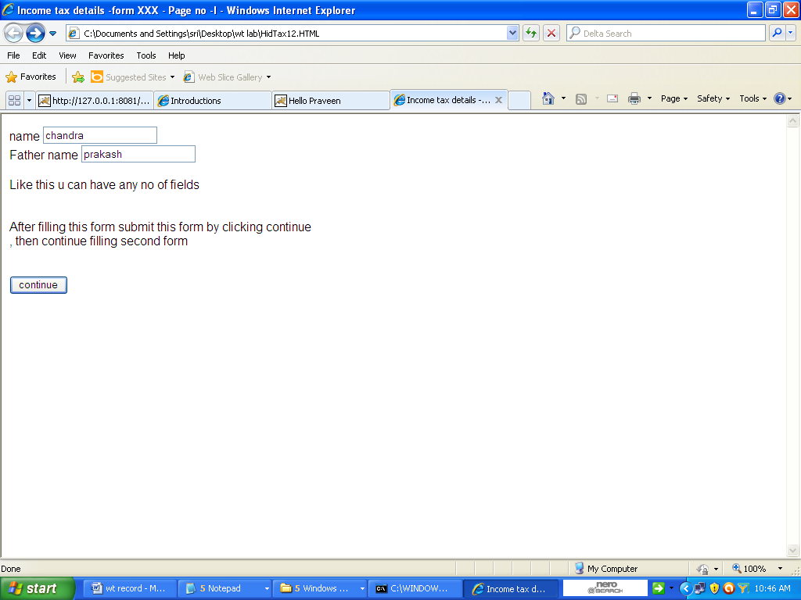

Output2

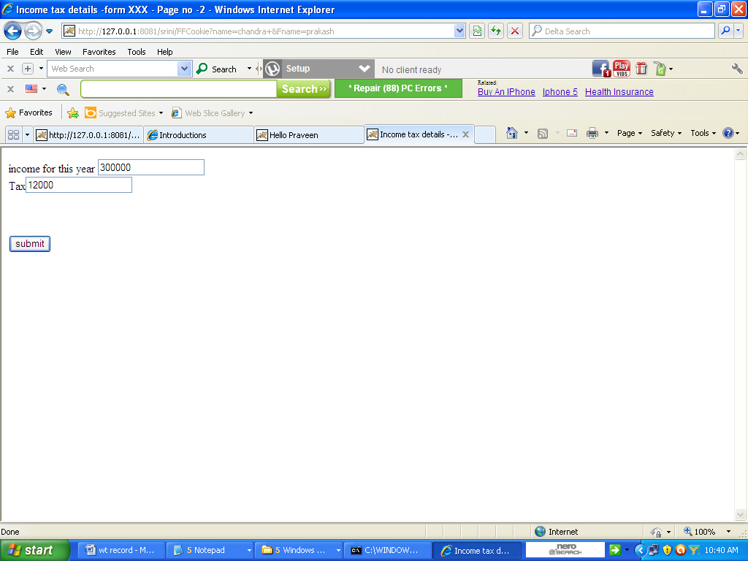

Output 3

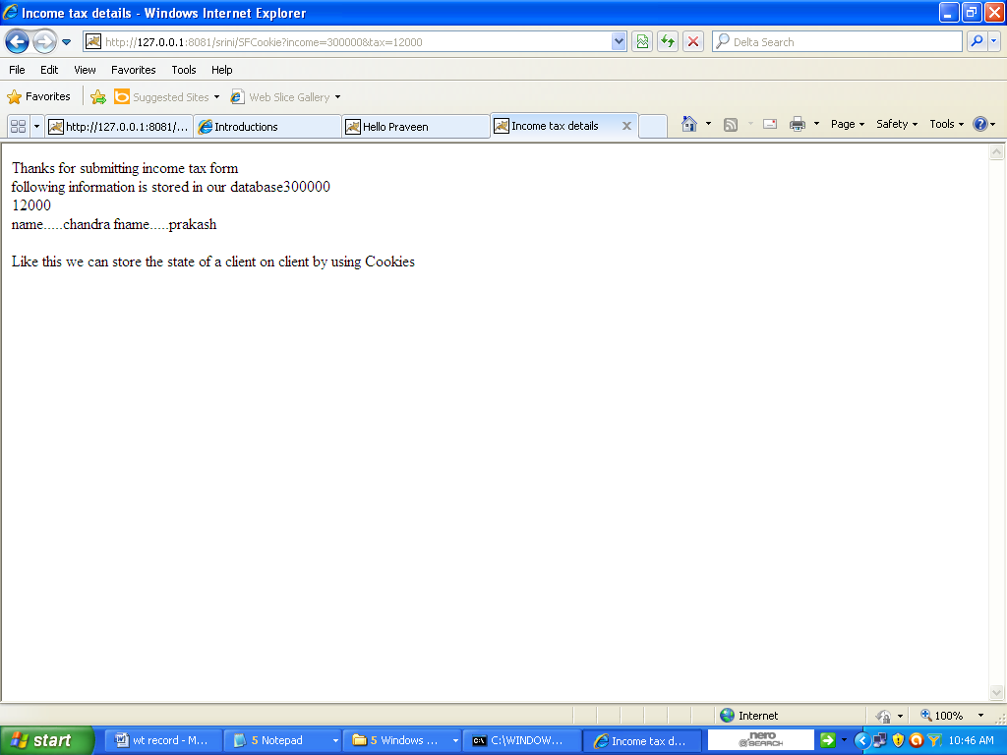

5. JSP PROGRAM TO PRINT CURRRET DATE & TIME

<HTML>

<HEAD>

<TITLE>JSP Example</TITLE>

</HEAD>

<BODY BGCOLOR="ffffcc">

<CENTER>

<H2>Date and Time</H2>

<%

java.util.Date today = new java.util.Date();

out.println("Today's date is: "+today);

%>

</CENTER>

</BODY>

</HTML>

OUTPUT

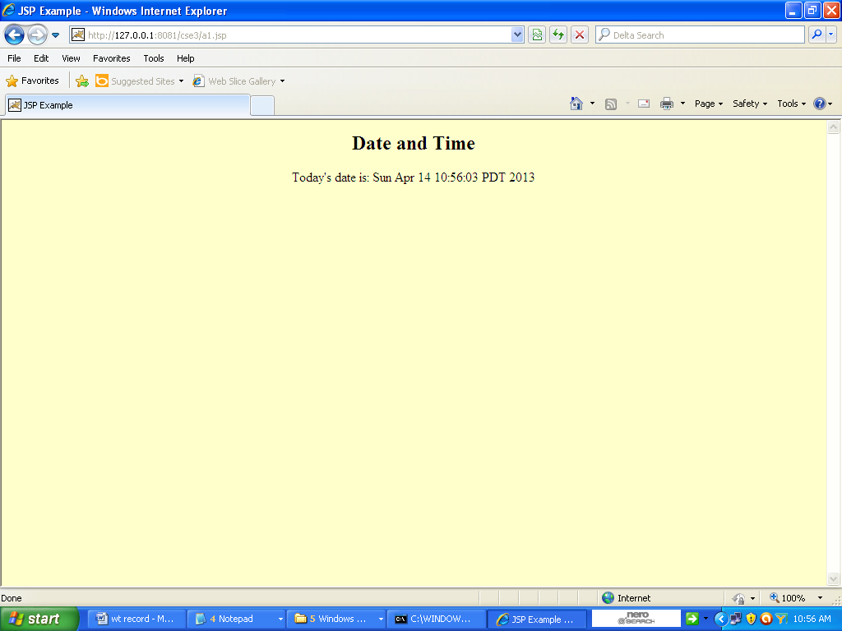

5. JSP PROGRAM USING CONTROL STRUCTURES AND INCLUDE DIRECTIVE

<html>

<head>

</head>

<body>

<%@include file= "a1.html" %>

<TABLE BORDER=2>

<%! int n =10; %>

<%

for ( int i = 0; i < n; i++ ) {

%>

<TR>

<TD>Number</TD>

<TD><%= i+1 %></TD>

</TR>

<%

}

%>

</TABLE>

</body></html>

**6.2 A1.HTML**

<html>

<head>

</head>

<body bgcolor = red>

<h1> it is the first page</h1>

</body>

</html>

**6.3 OUTPUT**

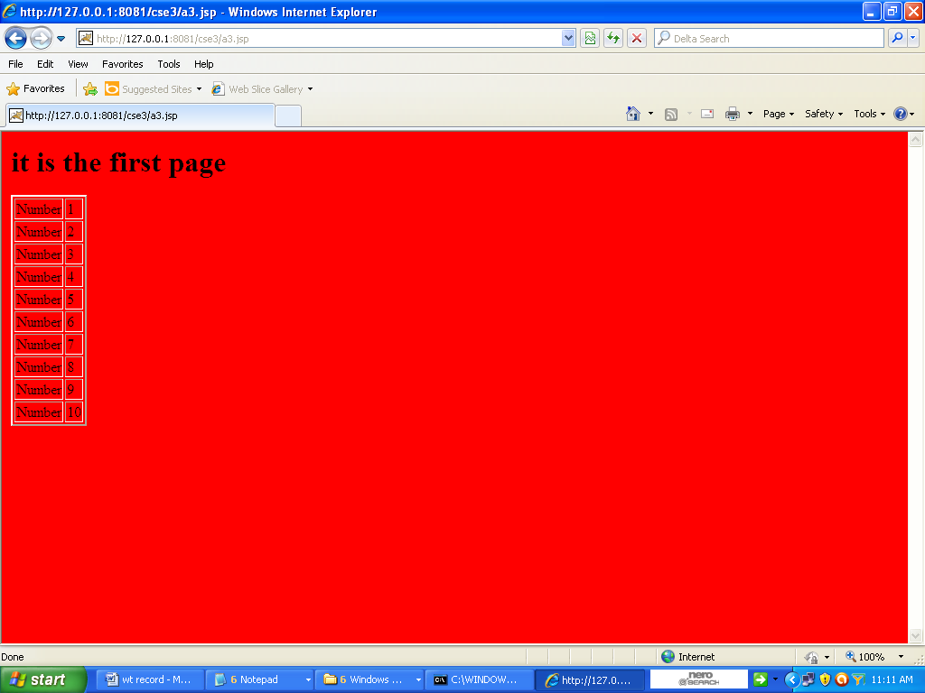

7. JSP PROGRAM TO HANDLE USER INPUT

**7.1 JSP PROGRAM(handleuserinfo.jsp)**

**<**html>

<head>

<title>JSP Form Demo</title>

</head>

<body>

<%

String firstName = request.getParameter("firstName");

String lastName = request.getParameter("lastName");

String email = request.getParameter("email");

%>

<p>Hi <%=firstName%> <%=lastName%>!,

your submitted email is <%=email%>.</p>

</body>

</html>

**7.2 HTML PROGRAM**

<html>

<head>

<title>JSP Form Demo</title>

<style type="text/css">

label{ margin-right:20px;}

input{ margin-top:5px;}

</style>

</head>

<body>

<form action=" http://127.0.0.1:8081/cse3/handleUserInfo.jsp" method="post">

<fieldset>

<legend>User Information</legend>

<label for="fistName">First Name</label>

<input type="text" name="firstName" /> <br/>

<label for="lastName">Last Name</label>

<input type="text" name="lastName" /> <br/>

<label for="email">Email</label>

<input type="text" name="email" /> <br/>

<input type="submit" value="submit">

</fieldset>

</form>

</body>

</html>

Output1

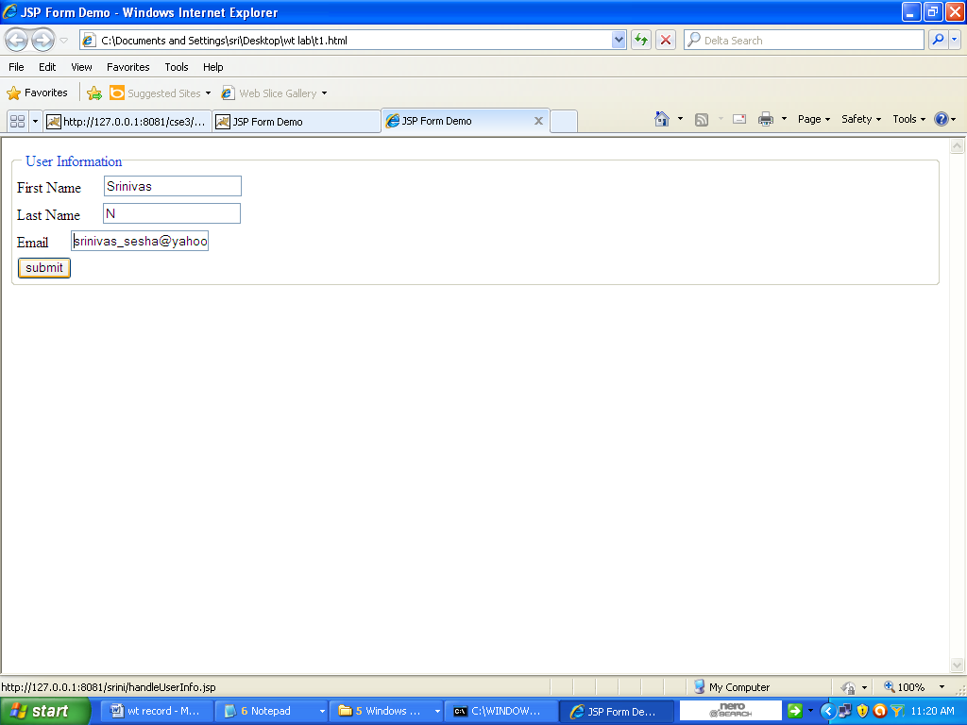

Output 2

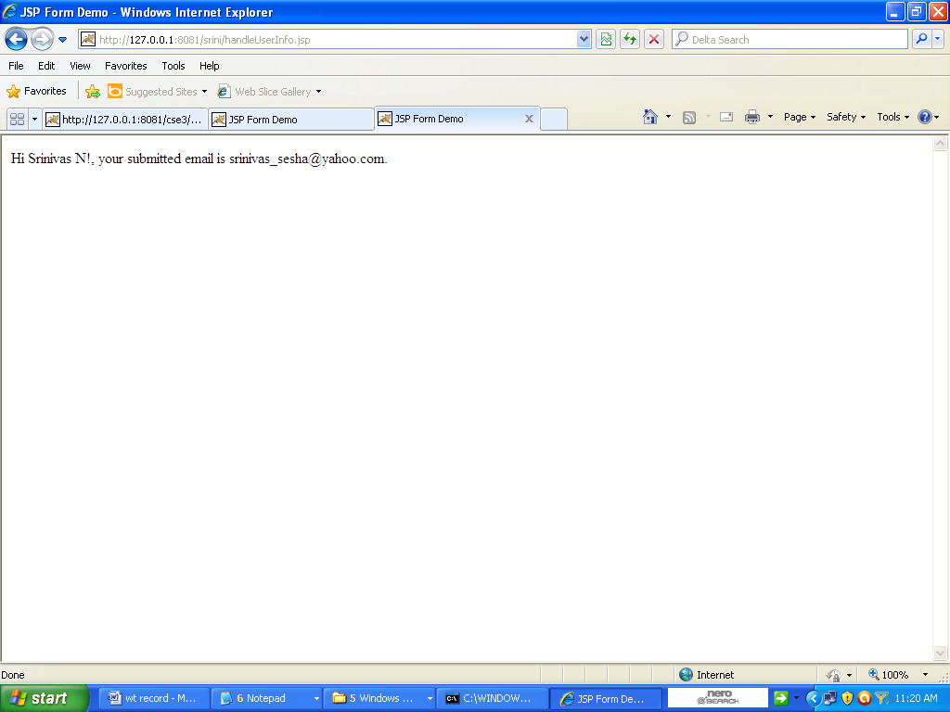

8. Servlet program to access data from the database(oracle 10g)

Steps in executing servlet program a to read data from Oracle (oracle database 10g express edition)

1. Assume that oracle user name : system

Password is : VBIT

1. OPEN ORACLE AND CREATE THE TABLE STUD

CREATE TABLE STUD( name varchar2(12), details varchar2(12));

Insert min of 4 records to the table

Step 2

1)The : oracle 10 g : database name is : xe

The port number in this system : 1521

2) The Driver is thin driver

3) The Jar file

C:\oraclexe\app\oracle\product\10.2.0\server\jdbc\lib\odbc14.jar

Added to the Env variable of Classpath

---------------

Step-3

Servlet program(JData1.java)

import java.io.*;

import javax.servlet.*;

import javax.servlet.http.*;

import java.sql.*;

import oracle.sql.*;

import oracle.jdbc.driver.*;

public class JData1 extends HttpServlet {

public void doPost(HttpServletRequest req,HttpServletResponse res) throws ServletException,IOException {

res.setContentType("text/html");

PrintWriter out = res.getWriter();

String msg=req.getParameter("msg");

System.out.println(msg);

try {

Class.forName("oracle.jdbc.driver.OracleDriver");

Connection conn = DriverManager.getConnection("jdbc:oracle:thin:@localhost:1521:xe","system","vbit");

Statement stmt=conn .createStatement();

ResultSet rs=stmt.executeQuery("select * from stud");

while(rs.next()){

out.println(rs.getString("name")+" "+rs.getString("details")+"<br>");

}

conn.close();

}

catch(Exception e){

System.out.println(e);

}

}

}

Step :4 Xml descriptor

Web.xml

<web-app>

<servlet>

<servlet-name>JData1</servlet-name>

<servlet-class>JData1 </servlet-class>

</servlet>

<servlet-mapping>

<servlet-name>JData1</servlet-name>

<url-pattern>/OraServlet1</url-pattern>

</servlet-mapping>

</web-app>

Step :5

The above program has to be accessed through a html page

<html>

<head.

</head>

<form action = "http://127.0.0.1:8081/cse3/OraServlet1" method = post>

enter your name

<input type = text name = "msg">

<br>

<input type = submit>

</form>

</html>

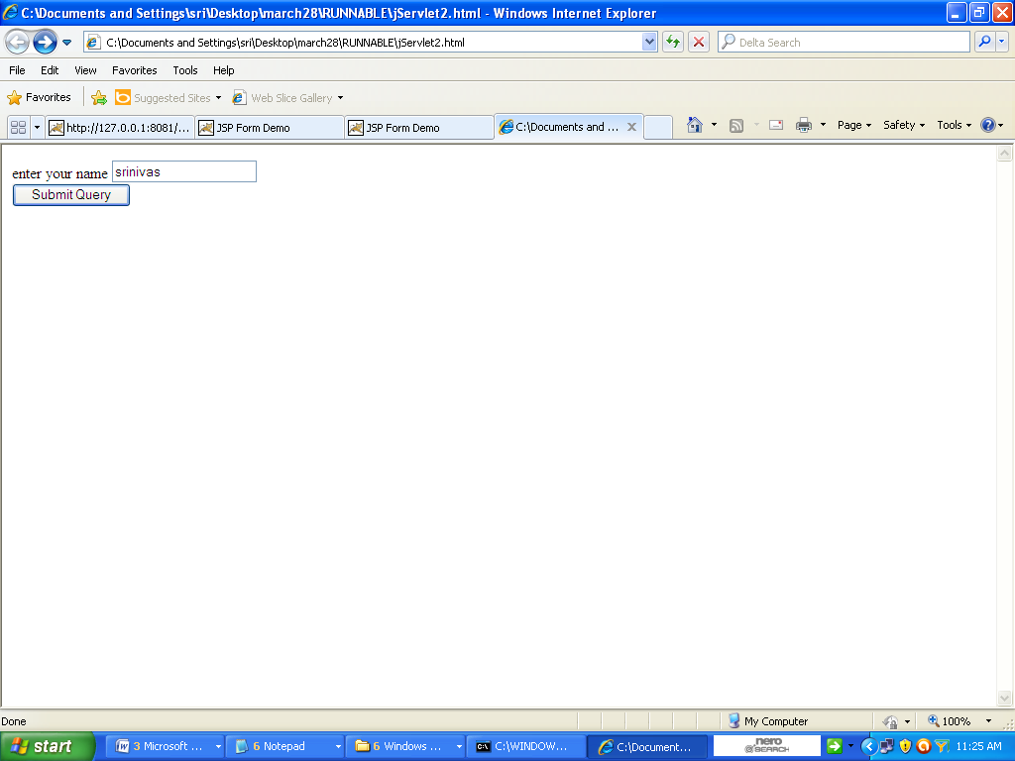

Output 2 : display of table using servlet program

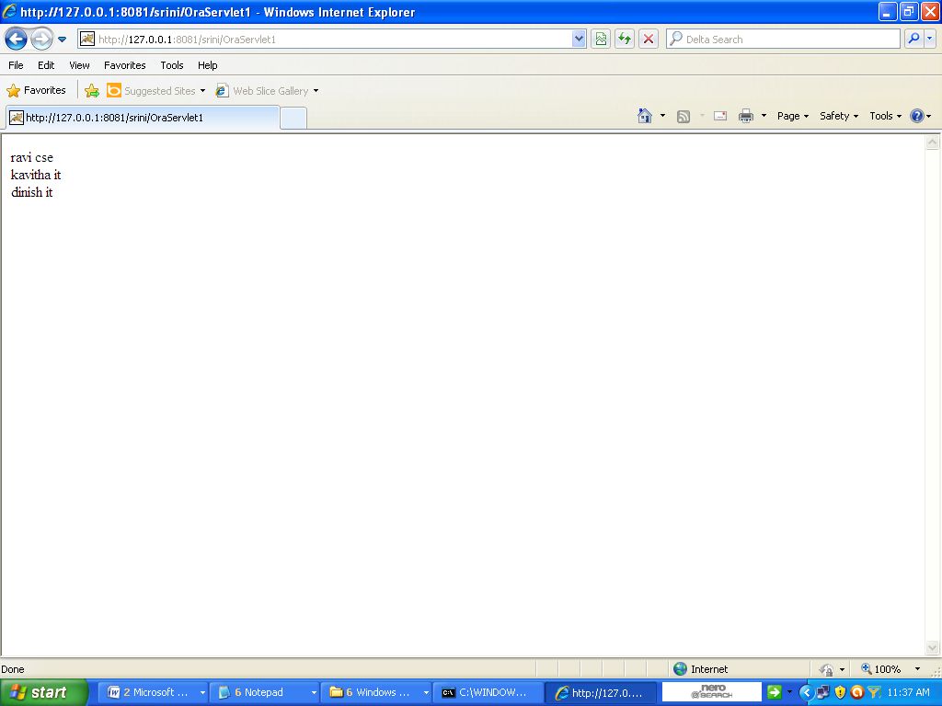

**9 Jsp program a to read data from Oracle (oracle database 10g express edition)**

Execution steps

1. Assume that oracle user name : system

Password is : VBIT

1. OPEN ORACLE AND CREATE THE TABLE STUD

CREATE TABLE STUD( name varchar2(12), details varchar2(12));

Insert min of 4 records to the table

Step 2

1)The : oracle 10 g : database name is : xe

The port number in this system : 1521

2) The Driver is thin driver

3) The Jar file

C:\oraclexe\app\oracle\product\10.2.0\server\jdbc\lib\odbc14.jar

has to be copied to

Lib directory of the Tomcat

(For example using tomcat 5.5 the Lib directory is )

C:\Program Files\Apache Software Foundation\Tomcat 6.0\common\lib

Step 3

Jsp program

<%@ page import = "java.sql.*" %>

<html>

<head>

<title> oracle</title>

</head>

<body>

<table bgcolor = yellow border = 5 cellpadding =10>

<tr>

<th> name</th>

<th> department</th>

</tr>

<%

try

{

Class.forName("oracle.jdbc.driver.OracleDriver");

Connection con = DriverManager.getConnection("jdbc:oracle:thin:@localhost:1521:xe","system","vbit");

Statement statement = con.createStatement();

ResultSet resultset = statement.executeQuery("select * from stud");

while(resultset.next())

{

%>

<tr>

<td> <%= resultset.getString(1) %> </td>

<td> <%= resultset.getString(2) %> </td>

</tr>

<%

}

out.println(" table created ");

}

catch(Exception e)

{

out.println(" an error occurred "+e);

}

%>

</table>

</body>

</html

Step 4:

Execute jsp program by typing the following in the address bar of the browser

http://localhost:8081/filename.jsp

output1

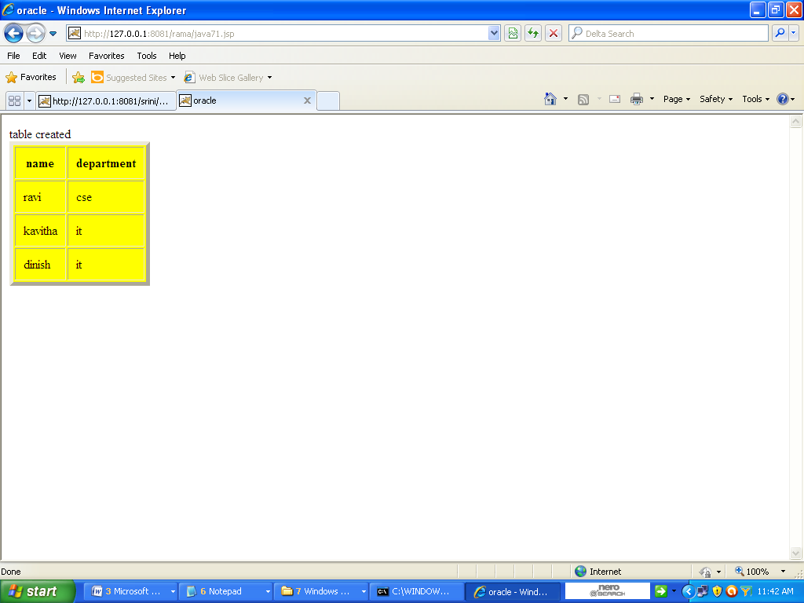

10.JDBC PROGRAM TO READ DATA THE FROM DATABASE

import java.sql.*;

import java.io.*;

import oracle.jdbc.pool.OracleDataSource;

class JdbcCheck

{

public static void main (String args[]) throws SQLException,IOException

{

String user, pwd, database;

user = "SYSTEM";

pwd = "abc";

database = "XE";

OracleDataSource ods= new OracleDataSource();

ods.setURL("jdbd:oracle:oci8:" +user +"/" +pwd +"@" +database);

Connection con = ods.getConnection();

System.out.println("connected");

Statement stmt = con.createStatement();

ResultSet rs= stmt.executeQuery(" select * from stud");

while(rs.next())

{

System.out.print(rs.getString("name") +"\t");

System.out.println(rs.getString("details"));

}

System.out.println(" conneection jdbc is installed correctly");

rs.close();

stmt.close();

con.close();

}

}

**output**

C:\javas>java JdbcCheck

connected

ravi cse

kavitha it

dinish it

conneection jdbc is installed correctly

C:\javas>